Тимофеева Наталья

М8О-202Б-19

Лабораторная работа № 15

**Описание работы**

В проекте VS реализовать пример работы паттерна Facade (с использованием элементов WinForm).

**Программа**

Form1.Designer.cs

namespace Lab15 {

partial class Form1 {

/// <summary>

/// Обязательная переменная конструктора.

/// </summary>

private System.ComponentModel.IContainer components = null;

/// <summary>

/// Освободить все используемые ресурсы.

/// </summary>

/// <param name="disposing">истинно, если управляемый ресурс должен быть удален; иначе ложно.</param>

protected override void Dispose(bool disposing) {

if (disposing && (components != null)) {

components.Dispose();

}

base.Dispose(disposing);

}

#region Код, автоматически созданный конструктором форм Windows

/// <summary>

/// Требуемый метод для поддержки конструктора — не изменяйте

/// содержимое этого метода с помощью редактора кода.

/// </summary>

private void InitializeComponent() {

this.groupBox1 = new System.Windows.Forms.GroupBox();

this.radioButton3 = new System.Windows.Forms.RadioButton();

this.radioButton2 = new System.Windows.Forms.RadioButton();

this.radioButton1 = new System.Windows.Forms.RadioButton();

this.groupBox2 = new System.Windows.Forms.GroupBox();

this.radioButton6 = new System.Windows.Forms.RadioButton();

this.radioButton5 = new System.Windows.Forms.RadioButton();

this.radioButton4 = new System.Windows.Forms.RadioButton();

this.groupBox3 = new System.Windows.Forms.GroupBox();

this.radioButton9 = new System.Windows.Forms.RadioButton();

this.radioButton8 = new System.Windows.Forms.RadioButton();

this.radioButton7 = new System.Windows.Forms.RadioButton();

this.button1 = new System.Windows.Forms.Button();

this.label1 = new System.Windows.Forms.Label();

this.groupBox1.SuspendLayout();

this.groupBox2.SuspendLayout();

this.groupBox3.SuspendLayout();

this.SuspendLayout();

//

// groupBox1

//

this.groupBox1.Controls.Add(this.radioButton3);

this.groupBox1.Controls.Add(this.radioButton2);

this.groupBox1.Controls.Add(this.radioButton1);

this.groupBox1.Location = new System.Drawing.Point(12, 12);

this.groupBox1.Name = "groupBox1";

this.groupBox1.Size = new System.Drawing.Size(105, 94);

this.groupBox1.TabIndex = 0;

this.groupBox1.TabStop = false;

this.groupBox1.Text = "Подарок";

//

// radioButton3

//

this.radioButton3.AutoSize = true;

this.radioButton3.Location = new System.Drawing.Point(6, 65);

this.radioButton3.Name = "radioButton3";

this.radioButton3.Size = new System.Drawing.Size(57, 17);

this.radioButton3.TabIndex = 2;

this.radioButton3.TabStop = true;

this.radioButton3.Text = "Кофта";

this.radioButton3.UseVisualStyleBackColor = true;

//

// radioButton2

//

this.radioButton2.AutoSize = true;

this.radioButton2.Location = new System.Drawing.Point(6, 42);

this.radioButton2.Name = "radioButton2";

this.radioButton2.Size = new System.Drawing.Size(55, 17);

this.radioButton2.TabIndex = 1;

this.radioButton2.TabStop = true;

this.radioButton2.Text = "Книга";

this.radioButton2.UseVisualStyleBackColor = true;

//

// radioButton1

//

this.radioButton1.AutoSize = true;

this.radioButton1.Location = new System.Drawing.Point(6, 19);

this.radioButton1.Name = "radioButton1";

this.radioButton1.Size = new System.Drawing.Size(70, 17);

this.radioButton1.TabIndex = 0;

this.radioButton1.TabStop = true;

this.radioButton1.Text = "Планшет";

this.radioButton1.UseVisualStyleBackColor = true;

//

// groupBox2

//

this.groupBox2.Controls.Add(this.radioButton6);

this.groupBox2.Controls.Add(this.radioButton5);

this.groupBox2.Controls.Add(this.radioButton4);

this.groupBox2.Location = new System.Drawing.Point(123, 12);

this.groupBox2.Name = "groupBox2";

this.groupBox2.Size = new System.Drawing.Size(99, 94);

this.groupBox2.TabIndex = 1;

this.groupBox2.TabStop = false;

this.groupBox2.Text = "Упаковка";

//

// radioButton6

//

this.radioButton6.AutoSize = true;

this.radioButton6.Location = new System.Drawing.Point(0, 65);

this.radioButton6.Name = "radioButton6";

this.radioButton6.Size = new System.Drawing.Size(68, 17);

this.radioButton6.TabIndex = 2;

this.radioButton6.TabStop = true;

this.radioButton6.Text = "Красная";

this.radioButton6.UseVisualStyleBackColor = true;

//

// radioButton5

//

this.radioButton5.AutoSize = true;

this.radioButton5.Location = new System.Drawing.Point(0, 42);

this.radioButton5.Name = "radioButton5";

this.radioButton5.Size = new System.Drawing.Size(68, 17);

this.radioButton5.TabIndex = 1;

this.radioButton5.TabStop = true;

this.radioButton5.Text = "Зелёная";

this.radioButton5.UseVisualStyleBackColor = true;

//

// radioButton4

//

this.radioButton4.AutoSize = true;

this.radioButton4.Location = new System.Drawing.Point(0, 19);

this.radioButton4.Name = "radioButton4";

this.radioButton4.Size = new System.Drawing.Size(56, 17);

this.radioButton4.TabIndex = 0;

this.radioButton4.TabStop = true;

this.radioButton4.Text = "Синяя";

this.radioButton4.UseVisualStyleBackColor = true;

//

// groupBox3

//

this.groupBox3.Controls.Add(this.radioButton9);

this.groupBox3.Controls.Add(this.radioButton8);

this.groupBox3.Controls.Add(this.radioButton7);

this.groupBox3.Location = new System.Drawing.Point(228, 12);

this.groupBox3.Name = "groupBox3";

this.groupBox3.Size = new System.Drawing.Size(138, 94);

this.groupBox3.TabIndex = 2;

this.groupBox3.TabStop = false;

this.groupBox3.Text = "Доставка";

//

// radioButton9

//

this.radioButton9.AutoSize = true;

this.radioButton9.Location = new System.Drawing.Point(0, 65);

this.radioButton9.Name = "radioButton9";

this.radioButton9.Size = new System.Drawing.Size(120, 17);

this.radioButton9.TabIndex = 2;

this.radioButton9.TabStop = true;

this.radioButton9.Text = "Доставка за 3 дня";

this.radioButton9.UseVisualStyleBackColor = true;

//

// radioButton8

//

this.radioButton8.AutoSize = true;

this.radioButton8.Location = new System.Drawing.Point(0, 42);

this.radioButton8.Name = "radioButton8";

this.radioButton8.Size = new System.Drawing.Size(126, 17);

this.radioButton8.TabIndex = 1;

this.radioButton8.TabStop = true;

this.radioButton8.Text = "Доставка за 1 день";

this.radioButton8.UseVisualStyleBackColor = true;

//

// radioButton7

//

this.radioButton7.AutoSize = true;

this.radioButton7.Location = new System.Drawing.Point(0, 19);

this.radioButton7.Name = "radioButton7";

this.radioButton7.Size = new System.Drawing.Size(84, 17);

this.radioButton7.TabIndex = 0;

this.radioButton7.TabStop = true;

this.radioButton7.Text = "Самовывоз";

this.radioButton7.UseVisualStyleBackColor = true;

//

// button1

//

this.button1.Location = new System.Drawing.Point(147, 135);

this.button1.Name = "button1";

this.button1.Size = new System.Drawing.Size(75, 23);

this.button1.TabIndex = 3;

this.button1.Text = "Заказать";

this.button1.UseVisualStyleBackColor = true;

this.button1.Click += new System.EventHandler(this.button1_Click);

//

// label1

//

this.label1.AutoSize = true;

this.label1.Location = new System.Drawing.Point(9, 182);

this.label1.Name = "label1";

this.label1.Size = new System.Drawing.Size(103, 13);

this.label1.TabIndex = 4;

this.label1.Text = "Ответ от магазина";

//

// Form1

//

this.AutoScaleDimensions = new System.Drawing.SizeF(6F, 13F);

this.AutoScaleMode = System.Windows.Forms.AutoScaleMode.Font;

this.ClientSize = new System.Drawing.Size(382, 225);

this.Controls.Add(this.label1);

this.Controls.Add(this.button1);

this.Controls.Add(this.groupBox3);

this.Controls.Add(this.groupBox2);

this.Controls.Add(this.groupBox1);

this.Name = "Form1";

this.Text = "Facade";

this.groupBox1.ResumeLayout(false);

this.groupBox1.PerformLayout();

this.groupBox2.ResumeLayout(false);

this.groupBox2.PerformLayout();

this.groupBox3.ResumeLayout(false);

this.groupBox3.PerformLayout();

this.ResumeLayout(false);

this.PerformLayout();

}

#endregion

private System.Windows.Forms.GroupBox groupBox1;

private System.Windows.Forms.RadioButton radioButton3;

private System.Windows.Forms.RadioButton radioButton2;

private System.Windows.Forms.RadioButton radioButton1;

private System.Windows.Forms.GroupBox groupBox2;

private System.Windows.Forms.RadioButton radioButton6;

private System.Windows.Forms.RadioButton radioButton5;

private System.Windows.Forms.RadioButton radioButton4;

private System.Windows.Forms.GroupBox groupBox3;

private System.Windows.Forms.RadioButton radioButton9;

private System.Windows.Forms.RadioButton radioButton8;

private System.Windows.Forms.RadioButton radioButton7;

private System.Windows.Forms.Button button1;

private System.Windows.Forms.Label label1;

}

}

Form1.cs

using System;

using System.Collections.Generic;

using System.ComponentModel;

using System.Data;

using System.Drawing;

using System.Linq;

using System.Text;

using System.Threading.Tasks;

using System.Windows.Forms;

namespace Lab15 {

public partial class Form1 : Form {

public Form1() {

InitializeComponent();

}

private void button1_Click(object sender, EventArgs e) {

int i1 = 0, i2 = 0, i3 = 0;

if (radioButton1.Checked)

i1 = 1;

else if (radioButton2.Checked)

i1 = 2;

else if (radioButton3.Checked)

i1 = 3;

if (radioButton4.Checked)

i2 = 1;

else if (radioButton5.Checked)

i2 = 2;

else if (radioButton6.Checked)

i2 = 3;

if (radioButton7.Checked)

i3 = 1;

else if (radioButton8.Checked)

i3 = 2;

else if (radioButton9.Checked)

i3 = 3;

if (i1 != 0 && i2 != 0 && i3 != 0) {

Present present = new Present(i1);

Packaging packaging = new Packaging(i2);

Delivery delivery = new Delivery(i3);

Label lab = label1;

Facade facade = new Facade(present, packaging, delivery);

facade.Order(lab);

}

else

MessageBox.Show("Вы не отметили все пункты");

}

}

class Present {

int i;

public Present(int n) {

i = n;

}

public double Find() {

if (i == 1)

return 10000;

else if (i == 2)

return 1000;

else

return 2500;

}

}

class Packaging {

int i;

public Packaging(int n) {

i = n;

}

string str = "Стоимость вашего заказа ";

public void Recolor(Label label, double price) {

if (i == 1) {

str += price.ToString();

str += " рублей";

label.Text = str;

label.ForeColor = Color.Blue;

}

else if (i == 2) {

str += price.ToString();

str += " рублей";

label.Text = str;

label.ForeColor = Color.Green;

}

else {

str += price.ToString();

str += " рублей";

label.Text = str;

label.ForeColor = Color.Red;

}

}

}

class Delivery {

int i;

public Delivery(int k) {

i = k;

}

public double Calculate(double price) {

if (i == 1)

return price;

else if (i == 2)

return price * 1.1;

else

return price * 1.05;

}

}

class Facade {

Present present;

Delivery delivery;

Packaging packaging;

public Facade(Present pre, Packaging pac, Delivery del) {

present = pre;

delivery = del;

packaging = pac;

}

public void Order(Label label) {

double price = present.Find();

double changedPrice = delivery.Calculate(price);

packaging.Recolor(label, changedPrice);

}

}

}

**Работа программы**

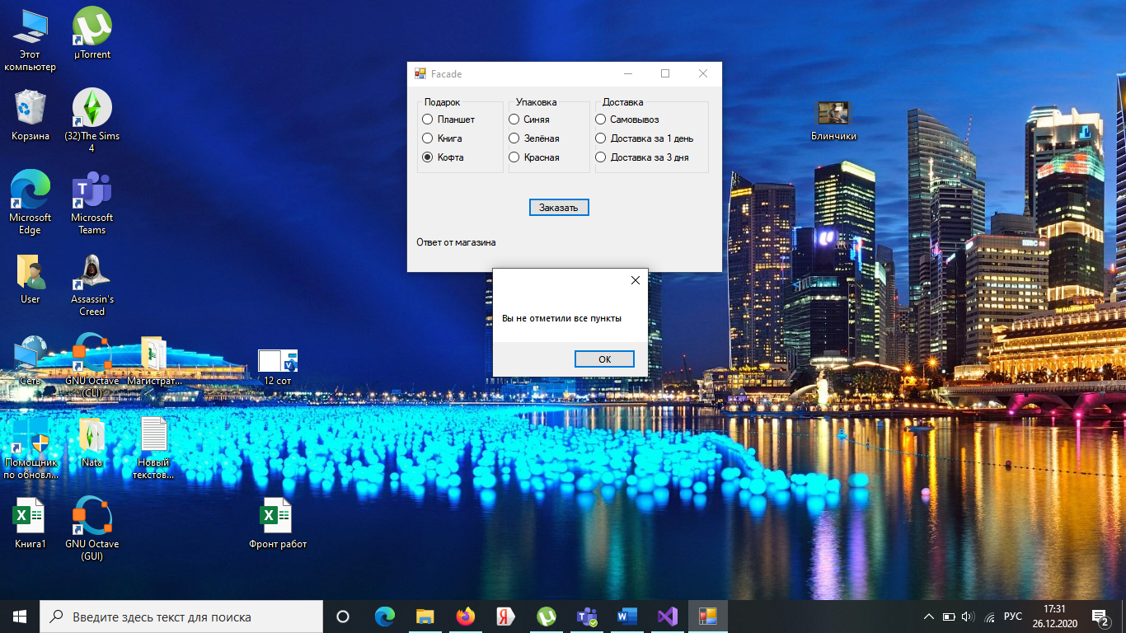

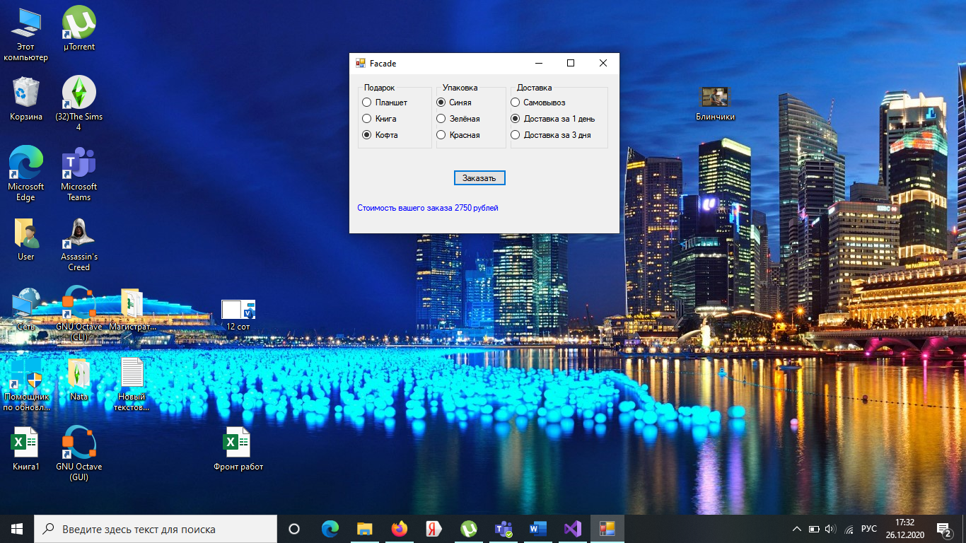

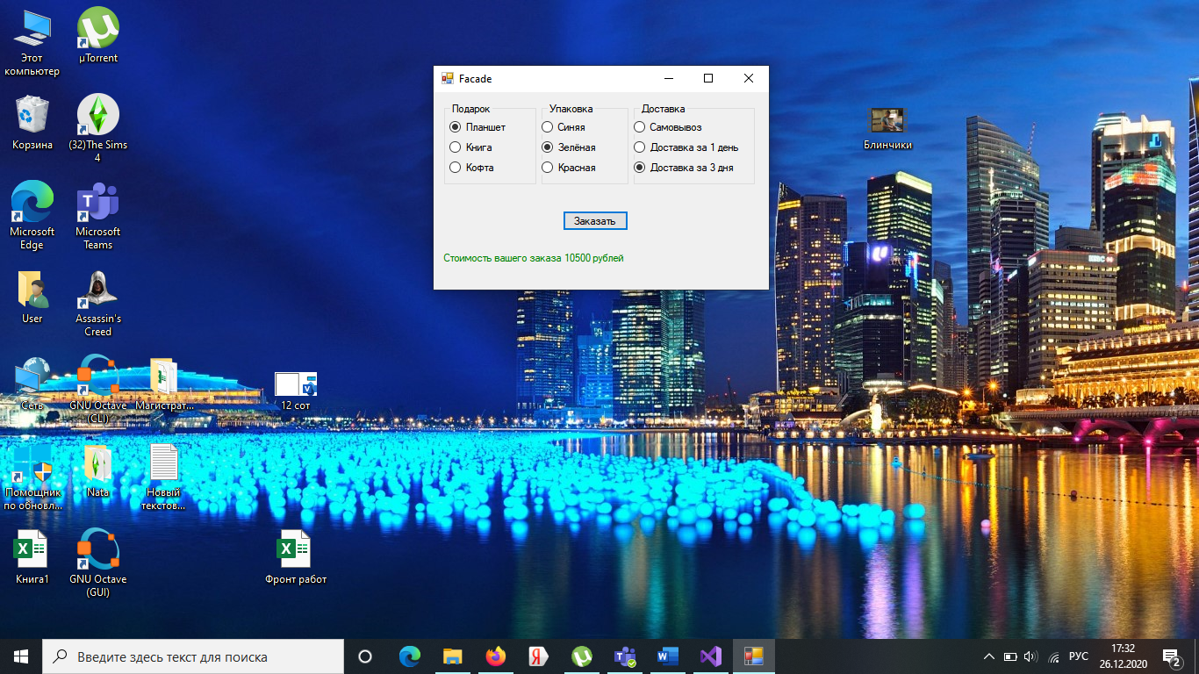

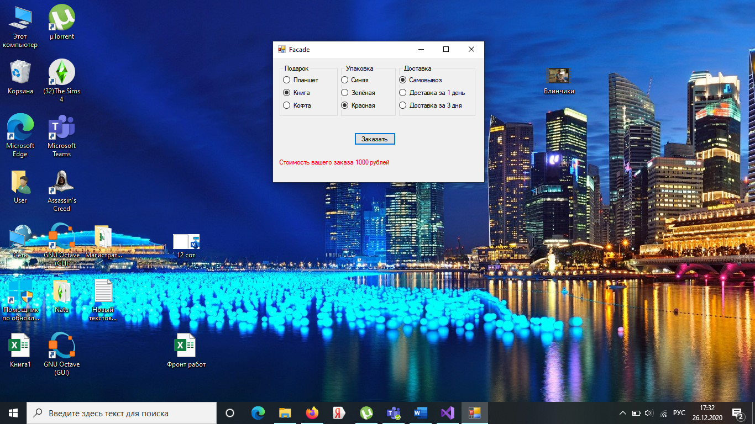

**Вывод**

Шаблон фасад (англ. Facade) — структурный шаблон проектирования, позволяющий скрыть сложность системы путём сведения всех возможных внешних вызовов к одному объекту, делегирующему их соответствующим объектам системы.

Применимость: когда вам нужно представить простой или урезанный интерфейс к сложной подсистеме; когда вы хотите разложить подсистему на отдельные слои.

Плюсы: изолирует клиентов от компонентов сложной подсистемы.

Минусы: фасад рискует стать объектом, привязанным ко всем классам программы.